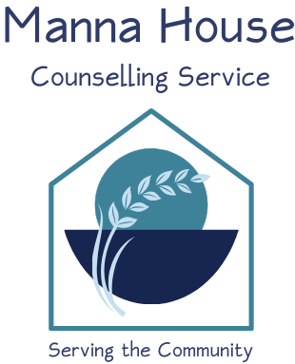

**The Manna House Counselling Service**

**Diploma in Christian Counselling**

**An Educational Level 4 Course – 420 hours**

**Who is this course for?**

This course is aimed at students who have completed a Level 3 counselling course (Certificate Level) and want to develop their knowledge and skills in order to gain the qualifications generally required by employers and accrediting bodies in this field.

**When does the course run?**

The course is run over two years on a Tuesday evening and involves one evening a week for 42 weeks during term-time (6:15 – 10:15pm) plus one Saturday per month (9.00am – 5.00pm with one hour lunch break) each year. Precise dates to be confirmed.

**What does the course cover?**

The course covers the following elements:

* Comparison of the philosophies of Non-Directive and Directive counselling as exemplified by Person Centred Counselling and Cognitive Counselling, and comparison with Biblical norms.
* Exploring the meaning of integration; the advantages and disadvantages of integration; the methods of integration; an exploration of some integrated models (in particular the MHCS 5 Circle Model); the integration of secular tools into a Christian model and use of creative interventions, integration of a skill/tool from another model into the 5 Circle Model.
* In-depth study of ACC (Association of Christians in Counselling & Linked Professions) code of practice and ethics as applied to counselling and a consideration of how they compare to Biblical values.
* An exploration of Brief Therapies and Solution Focused Brief Therapies.
* Understanding the responsibilities of a counsellor in respect of supervision and how to get maximum benefit from one’s own supervision.
* To consider how counsellors can maintain quality of service and monitor outcomes in their counselling.
* An in-depth look at some of the issues that clients present with in counselling such as: depression; anxiety, eating disorders; grief and loss plus autism.

Underlying these topics will be issues of personal awareness and development and research into current growth areas in counselling. These will run concurrently with the other topics. For the research topic, each student will be required to present a minimum of 2 short presentations to the rest of the group over the duration of the course.

**Counselling Placement**

As well as the academic requirement of the course, each student must complete 100 hours of supervised counselling. A student may apply to the Manna House or organise/find their own placement (only in exceptional circumstances would a student be refused). Placements elsewhere must be with a recognised counselling organisation with experience of student placements. On completing the placement should a student wish to continue working as a volunteer counsellor for the Manna House they will need to apply and undergo a formal interview.

**What qualifications does the course give me?**

The course is recognised by the Association of Christian in Counselling & Linked Professions (ACC) and other professional counselling bodies such as the BACP. On successful completion of the course a student can apply to go onto ACC’s Professional Register for accreditation with the ACC.

It is validated by the Counselling and Psychotherapy Central Awarding Body (CPCAB), who are the UK’s leading counselling awarding organisation. This means that any employer should accept its awards as valid qualifications. Our Level 4 Diploma can provide entry into studying counselling at degree or Masters level.

**What does the course involve?**

The student must attend a minimum of 85% of the course. This means only being able to miss 63 hours of the course.

Every student on the course will need to register as a student member of the ACC or similar governing body. If you are not already a member then you will need to have enrolled by the start date or as soon as possible. Manna House is an affiliate member of ACC and the current membership rate for a L4 student is £57.90 (please note this may change).

Students must provide evidence of having achieved all the course Learning Criteria. This is achieved by completing an e-portfolio of evidence. There is a timetable for criteria to be submitted – this will be given to students at the beginning of each academic year and must be achieved for each set year. A ‘Readiness to Counsel’ assessment must be achieved by the end of the first year to enable the student to progress to Year 2 of the course and start their placement.

**Students should achieve all learning criteria by the end of the course. They will have up to 12 months after this to complete their 100 hours counselling placement if needed.**